DT  Choose your favourite toy. Can you take him/her on a journey today? Where did you go? What did you see? #year1holyfamily. | LITERACY  Make a diary of your journey today. | HISTORY  How have toys changed over time? Can you draw a toy from a previous year, maybe war time. How would you play with that toy?  . 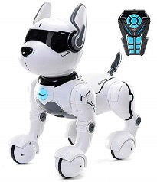
SCIENCE  Look in your toy box. Which toys need different forces to move. Do they move easier on different materials? Do some need batteries. Which ones do you keep outside and why? | MATHS  There are 4 cars in the toy box and 4 toys downstairs. Also 8 cars in the attic. How many cars in the house altogether? | PSHE  Create a game using two of your toys and write a list of rules. Can you include a member of your family and explain how they play?
Why are our toys more fun than what our grandparents played with?
Dogger
DT  Design a new toy using items and materials from your home. How would you use it. Draw it and label it.  Can you tweet it? | CREATIVITY/ART  Can you play with a toy that you haven’t played with before? Maybe a family members, maybe a friends? | RE  Write a paragraph about a time where you have shared toys with somebody. How did it make you feel?  Is there a time where somebody has shared with you?

