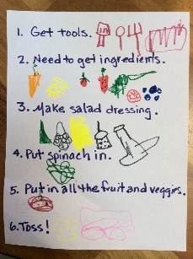  DT  Make a colourful salad with grown up. Remember be careful with your chopping.  #year1holyfamily. | LITERACY  Make a diary of the fruit and vegetables you eat in one day. You could draw pictures or make a list. | GEOGRAPHY  Can you find out any fruit or vegetables that grow in different countries? You could look in books, or on the internet or even talk to your grow up, watch a TV programme  .
SCIENCE/LITERACY  Draw a picture of a vegetable growing, label instructions of how you would look after the vegetable. What would it need to grow? | MATHS  There are 9 carrots in a veg patch, you took 3 carrots to eat with you evening meal tonight. How many carrots do you have left for the rest of the week? | PSHE  Children in your class like to eat McDonalds and chips each day. Talk to your adult and write down some facts about why this isn’t a healthy diet?  What sort of food and drink should they be eating?
How can we grow our own salad?
Lizzie and the birds
SPELLINGS – How many words can you spell? | CREATIVITY/ART  Make a smiley face out of the food on your plate. Ask an adult to tweet it. What did you enjoy about your food. | RE  Easter is fast approaching. What types of food are popular in the Catholic faith around this time.  Could you explain why?

