PSHE  Ask a grown-up or friend to sing ‘10 Little Men in a Flying Saucer’ with you. You could use your fingers to be the men in the flying saucer and put one down when you sing, “one man flew away.” | ART  Design your own planet. Draw a picture of it and think about what shape and colours it might be. What would you call it? Use your phonics sounds to write the name of the planet. Ask a grownup to help you write some adjectives to describe your planet. | COMMUNICATION  Think about what the aliens might do with the underpants. You could tell a friend, or someone in your family. You could even draw a picture of what you think they use the underpants for.
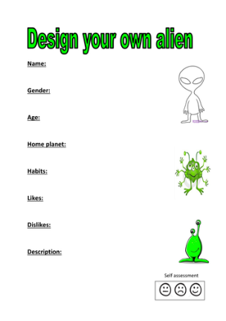ART Design your own Alien. | DT  Ask a grown-up if you can have some recycled materials from your house. Use these to build a spaceship. It could be a small model, big enough to fit a teddy bear inside, or even big enough to fit you! | PSHE  You could help hang out the washing on the line. See how many items of clothing you can count hanging on the line.
What do aliens think of life on planet Earth?
Alien loves underpants

ART/ LITERACY  Draw what you have inside your house to help the alien to come and visit. Remember you need to tell him what they are and what they are used for. | LITERACY  An Alien has landed. How can you describe what planet earth is like. Write a letter to explain to him what you like about your life. | LITERACY  How many words can you think of that rhyme with ‘space’? See if you can write down 3.

