MATHS  Can you record the day and the weather change for the next 7 days? Remember to write it down and tweet your findings. You can always draw a picture of the weather too. | NATURE/ PE  Go for a walk with your grown up and spot the signs of spring. What did you find? Write a diary about your journey. | PE  Let’s sing and dance!  https://www.youtube.com/watch?v=8ZjpI6fgYSY
ART/DT  Make a picture with the recyclable rubbish in your house? What colours will you use for winter? Which colours would you use for summer.  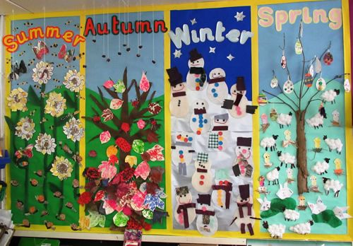 | GEOGRAPHY  What is the weather like around the world?  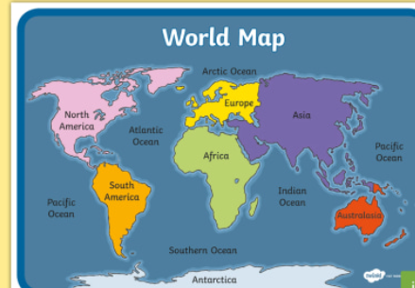  Draw what the weather is like in Africa today? | CREATIVITY  Create a teddy bears picnic. You can invite three people. Who would they be and why? Take pictures and tell us what you included in your picnic.
Why does it get darker earlier in the winter?
(Can you sleep little Bear)
PSHE https://www.youtube.com/watch?v=Fv1UTnSsRPM  Watch the link.  How are you feeling today?  Can you create a dance to show the seasons. | HISTORY  What teddy bears do you have? Can you remember who bought them for you?  What your history behind your toys. Tell a story about your teddy bears. | SCIENCE  Are the plants changing outside?  What can you see?  Can you water the plants outside? Can you create a game outside?

