LITERACY  Write a story, including a character of a tiger. | ART  Draw a picture of a tiger. | CREATIVITY  Create your own tea party in your home and take a picture, tweet it #year1HolyFamily
LITERACY  Watch this video https://www.youtube.com/watch?v=jEQaRY4YpVo  Can you think describe what a tiger looks like?  Remember your describing words.  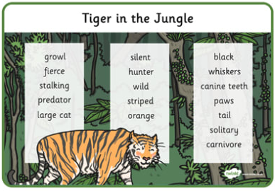 | GEOGRAPHY  Where in the world would you find a tiger?  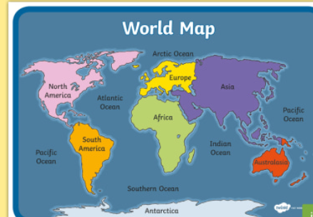 | PE  Can you crawl like a tiger? How would they walk? How would they act? What would they sound like?  # year1HolyFamily
Why are Humans Not Like Tigers?
( The Tiger that came for tea)
MATHS  Which other big cats do you know about?  Can you draw them and order them largest to smallest.  https://www.youtube.com/watch?v=8cQmky_wQao | ART/LITERACY  Oh No! A Tiger has escaped from the Zoo!  Can you create a poster to find him?  Persuade people that the tiger who came for tea is not mean and would not hurt people. | ART Can you draw those tiger stripes? Try and focus on counting how many stripes you need? How many different patterns can you create?

