MATHS  Build a dinosaur using different 2D shapes.  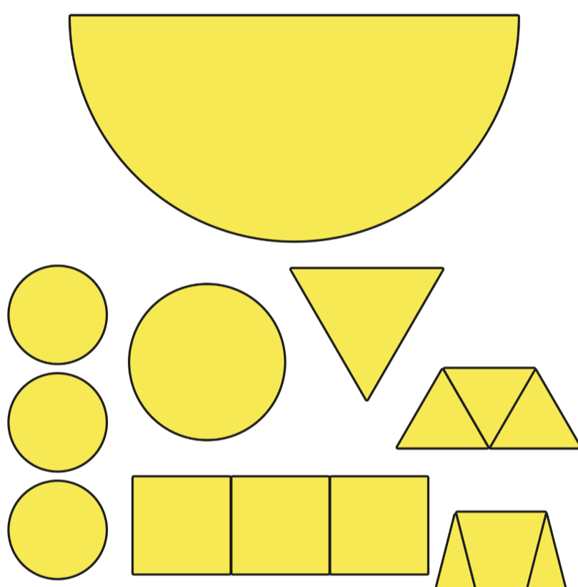 | ART  Draw a dinosaur and colour it. Can you label it using simple sentences. | PE  Can you walk like a Tyrannosaurus Rex. How would you move? How would you sound?Tweet it #year2HolyFamily
LITERACY  Can you create a dinosaur fact file. | DT  Can you make a dinosaur out of items you have at home? Maybe Lego or egg cups? | DRAMA  Can you create a mask to wear? Create your dinosaur mask and act out a scene from a dinosaur story. 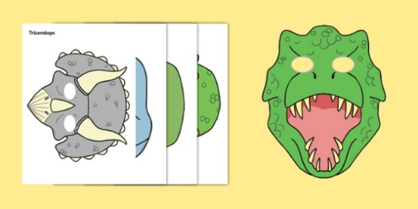
Would a dinosaur make a good pet?
Tyrannosaurus drip.
ART /DT  Can you make a dinosaur egg out of food or maybe flour? 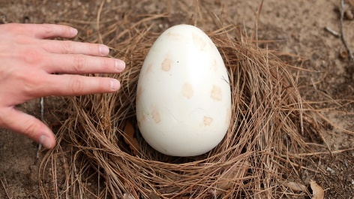 | PSHE /SCIENCE  Can you create a habitat that would be welcoming to a dinosaur? Write why it is suitable for the dinosaur? | PSHE  Go outside and lie down. Look at the clouds. Can you see the shape of a dinosaur forming in any of their movements? Take a picture. Tweet it  #year2HolyFamily

